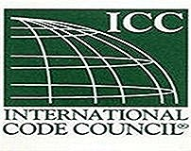
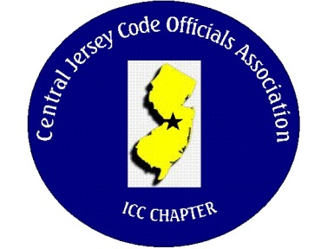
CJCOA

Central Jersey Code Officials Association

Call to Order: President John White called the meeting to order on February 7, 2024 at 12:10 pm with 52 in attendance.

Guest Speaker: Noah Humbertson of APA Plywood who spoke about portal framing details and the common framing mistakes.

Approval of Minutes: Minutes were approved.

Correspondence: None

Treasurer’s Report: Read by Treasurer Nick Van Wagner

Legislative Report: None

Finance & Audit Committee. Conducted and concluded.

Education Committee: Charles Alfieri from Tenmat and will be talking about their passive fire protection products.

Membership Committee: Members who are paid in full to date. 24
Life Members. 22
Associate members: 3

By-Laws Committee: No Report

Historical Committee: No Report

Good & Welfare Committee: Frank Kopec’s wife passed away and a sympathy card was sent from the association.

Public Relations: Facebook

Code Change Committee:

Building: Homeowner drawings can be accepted digitally since no raised seal is required.

Electric: No Report

Plumbing: No Report

Fire: No Report

Nominating Committee: No Report

Scholarship Committee: No Report

Website Committee: Working on fixing the issues.

Golf Committee: The golf outing will be on Thursday June 6, 2024 at Mercer Oaks.

Ad-Hoc: Building Safety will be held at the Hard Rock Hotel in Atlantic City on May 8, 9 & 10.

DCA: No Report

ICC: No Report

ICC-Region 7: No Report

Unfinished Business: None

New Business: Central Jersey Code Officials Association is partnering with “Bridging the Gap”
This group is responsible for assisting service members find employment in the construction
Industry when their service with the military is complete.

Announcements: DCA seminars are online except for the live seminars at the Building Safety Week.
Ideas Show will be March 13th. at the Valley Forge Casino. Registration and attendance are free for anyone who would like to attend.
Pemberton is looking for a Part-Time Plumbing and Mechanical inspector in addition to a Part-Time Electrical inspector.

Meeting was adjourned: 1:49

Respectfully Submitted,

Frank Oliveti
Secretary

