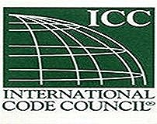
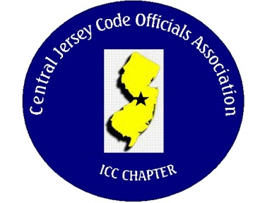
CJCOA

Central Jersey Code Officials Association

Call to Order: President Rich Perlman called the meeting to order on February 1, 2023 at 12:03 pm with 38 in attendance.

Guest Speaker: Greg Lavardera of Warm Foam Insulation Slab Forms. Greg spoke about the proper methods to install the forms for code compliance.

Approval of Minutes: Minutes were approved.

Correspondence: A thank you letter was received from the Sunshine Foundation thanking our organization for the generous donation which will be used to send Andrew to California for the National Organization for Albinism and Hypopigmentation conference.
We also received a letter from our guest engineering student Danny thanking us for the invitation and to tell us how much he enjoyed hearing the code discussions.

Treasurer’s Report: Read by Treasurer Joe Voacola

Legislative Report: No Report

Finance & Audit Committee. No Report

Education Committee: March 1 guest speaker will be Michael Shell – Delta Dry Ventilation Screen. Michael will be discussing the ventilated screen application requirements for adhered stone and conventional stucco.

Membership Committee: Members paid in full to date. 165
Life Members. 22
New Members:

By-Laws Committee: No Report

Historical Committee: No Report

Good & Welfare Committee: No Report

Public Relations: Facebook is active and there are postings every so often.

Code Change Committee:

Building: No Report

Electric: No Report

Plumbing: No Report

Fire: No Report

Nominating Committee: No Report

Scholarship Committee: Adam Gee will be the new chairman.

Website Committee: Please provide any job postings to our webmaster Joe Voacola.

Golf Committee: The date for the golf outing will be June 8 @ Mercer Oaks. More details to follow. The committee is looking for volunteers to help with our biggest fund raising event.

Ad-Hoc: No Report

DCA: No Report

ICC: No Report

ICC-Region 7: No Report

Unfinished Business: The Chairman of the electrical board has clarified the licensing classifications. Class A Journeyman. Class A Electrical Apprentice. Class B Wireman.

New Business: No report

Announcements: Building Safety Week will be May 3, 4 & 5 in Atlantic City. More details to follow.

Meeting adjourned: 2:08 PM

Respectfully Submitted,

Frank Oliveti
Secretary

