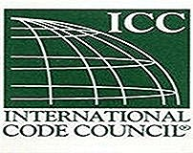
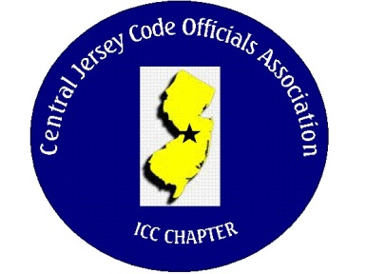
CJCOA

Central Jersey Code Officials Association

Call to Order: President Rich Perlman called the meeting to order on October 4, 2023 at 12:07 pm with 31 in attendance.

Guest Speaker: Christina Tamborell, Holly Foster and Allison Chris Myres of the Civil Service Commission. Also in attendance were Charles Nieves & Verlensky Joachim who are License Examiners with the DCA.

Approval of Minutes: Minutes were approved.

Correspondence: No Report

Treasurer’s Report: Read by Treasurer Joe Voacola

Legislative Report: No Report

Finance & Audit Committee. No Report

Education Committee: Joe Reilly – Royal Building Products. Joe will be speaking about Royal products that include roofing, siding, decking, exterior trim and composite stone.

Membership Committee: Members paid in full to date. 138
Life Members. 22
Associate Members: 35

By-Laws Committee: No Report

Historical Committee: No Report

Good & Welfare Committee: Our long time member, colleague and friend Tony Scelsa passed away at home on October 2, 2024. CJCOA will send a $50.00 donation to St. Jude’s Hospital in Tony’s name.

Public Relations: Facebook is active and there are postings every so often.

Code Change Committee:

Building: No Report

Electric: The 2023 NEC may skip a cycle and adopt the 2026 NEC when approved.

Plumbing: No Report

Fire: No Report

Nominating Committee: John White – President. Joe Voacola – Vice President. Nick Van Wagner – Treasurer. Frank Oliveti –Secretary (floor nomination)

Building Safety Week: No Report

Scholarship Committee: (2) College or Trade School scholarships and (1) High School Merit scholarship will be awarded this year. Please go to CJCOA.org for the downloadable version.

Website Committee: The ABM year date will be corrected on the website.

Golf Committee: No Report

Ad-Hoc: No Report

DCA: No Report

ICC: No Report

ICC-Region 7: No Report

Unfinished Business: None

New Business: Contractor Don Caso brought a question to the members about the Res-Check program and having diffulcty passing with his imputes. The DCA will have in person Seminars in October. The DCA may give Plumbing, Fire, Electric or Mechanical CEU’s for attending CJCOA meetings. John White is in negotiations with Patrick Ryan of the DCA.

Announcements: The Executive Board has decided to make Tony Scelsa a “Lifetime Member Posthumously” This award will take place at the ABM.

Meeting adjourned: 1:25 PM

Respectfully Submitted,

Frank Oliveti
Secretary

