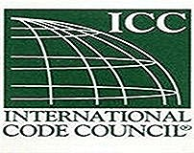
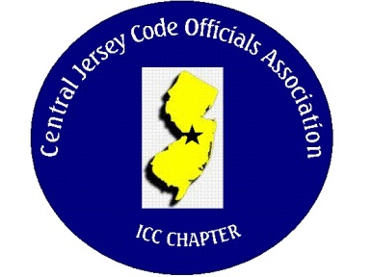
CJCOA

Central Jersey Code Officials Association

Call to Order: President Rich Perlman called the meeting to order on May 3, 2023 at 12:05 pm with 26 in attendance.

Guest Speaker: Matt Suckley from Eaton

Approval of Minutes: Minutes were approved.

Correspondence: No Report

Treasurer’s Report: Read by Treasurer Joe Voacola

Legislative Report: No Report

Finance & Audit Committee. No Report

Education Committee: June 7 guest speaker will be Michal Hofkin from UL and will be discussing securing, supporting and connecting NM cable (Part II).

Membership Committee: Members paid in full to date. 105
Life Members. 22
Associate Members: 39

By-Laws Committee: No Report

Historical Committee: No Report

Good & Welfare Committee: A get well card was received from Rich Such who is recovering from surgery.

Public Relations: Facebook is active and there are postings every so often.

Code Change Committee:

Building: No Report

Electric: No Report

Plumbing: No Report

Fire: No Report

Nominating Committee: No Report

Building Safety Week: May 3, 4 & 5 at The Hard Rock in Atlantic City

Scholarship Committee: Adam Gee will be the new chairman.

Website Committee: Please provide any job postings to our webmaster Joe Voacola.

Golf Committee: The date for the golf outing will be June 8 @ Mercer Oaks. More details to follow. The golf committee is looking for volunteers and gifts for door prizes.

Ad-Hoc: No Report

DCA: No Report

ICC: No Report

ICC-Region 7: No Report

Unfinished Business: We are discussing how CJCOA can be involved with trade schools.

New Business: No report

Announcements: Brian Miller (Director of Code Enforcement & Construction Official of Plainsboro Twp.) has been selected as “Construction Official of the Year” by MUNCO and will be honored at Building Safety Week.

Meeting adjourned: 1:20 PM

Respectfully Submitted,

Frank Oliveti
Secretary

