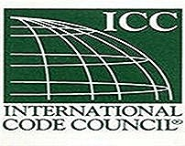
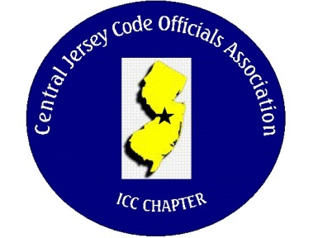
CJCOA

Central Jersey Code Officials Association

Call to Order: President John White called the meeting to order on January 3, 2024 at 12:07 pm with 28 in attendance.

Guest Speaker: Dwight Stone of Johns Manville who flew in from Colorado to be our guest speaker.

Approval of Minutes: Minutes were approved.

Correspondence: None

Treasurer’s Report: Read by Treasurer Nick Van Wagner

Legislative Report: None

Finance & Audit Committee. Will occur on January 31.

Education Committee: Noah Humbertson from APA plywood Association and will be speaking about portal framing and the identification of common framing errors.

Membership Committee: Members are paid in full to date. 0
Life Members. 22
Associate members: 0
By-Laws Committee: No Report

Historical Committee: No Report

Good & Welfare Committee: Shelley Merola the Technical Assistant of Lawrence passed away. Flowers were sent from the association.

Public Relations: Facebook

Code Change Committee:

Building: No Report

Electric: No Report

Plumbing: No Report

Fire: No Report

Nominating Committee: No Report

Scholarship Committee: No Report

Website Committee: The 2024 membership applications can be found on our website CJCOA.org

Golf Committee: The golf outing will be on Thursday June 6, 2024 at Mercer Oaks.

Ad-Hoc: No Report

DCA: No Report

ICC: No Report

ICC-Region 7: No Report

Unfinished Business: None

New Business: None

Announcements: DCA seminars are online

Meeting was adjourned: 1:47

Respectfully Submitted,

Frank Oliveti
Secretary

