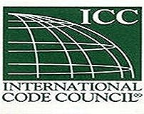
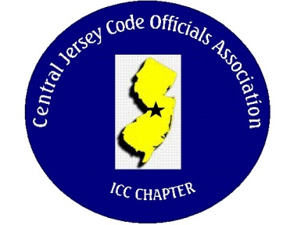
CJCOA

Central Jersey Code Officials Association

Call to Order: President Rich Perlman called the meeting to order on November 1, 2023 at 12:06 pm with 40 in attendance.

Guest Speaker: Paul Touroojian of Allegiant Wireless who discussed the emergency responder communication requirements in buildings required by the building code.

Approval of Minutes: Minutes were approved.

Correspondence: We received a thank you letter from the mayor of Woodbridge for the contribution to the Construction Official Tommy Kelly fund to assist him and his family navigate the many issues associated with his recovery.

Treasurer’s Report: Read by Treasurer Joe Voacola

Legislative Report: No Report

Finance & Audit Committee. Will be completed by the ABM

Education Committee: No general membership meeting will be held in December. The annual business meeting will be held on Thursday December 14 at 12:00 at La Piazza Restaurant. RSVP’s will be required by December 7th. Any member who has not paid their dues for the year will be required to pay $55.00 at the door. Guests are invited to attend for the price of $40.00 per person.

Membership Committee: Members paid in full to date. 138
Life Members. 22
Associate Members: 35

By-Laws Committee: No Report

Historical Committee: No Report

Good & Welfare Committee: No report

Public Relations: Facebook is active and there are postings every so often.

Code Change Committee:

Building: No Report

Electric: No Report

Plumbing: No Report

Fire: No Report

Nominating Committee: John White – President. Joe Voacola – Vice President. Nick Van Wagner – Treasurer. Frank Oliveti –Secretary. There were no nominations from the floor, therefore the names mentioned will be the new Officers for the years 2024 & 2025. They will be sworn in at the ABM next month.

Building Safety Week: No Report

Scholarship Committee: We have received (3) applications for scholarships by the November 1st. deadline. Winners will be announced at the ABM.

Website Committee: No Report

Golf Committee: No Report

Ad-Hoc: No Report

DCA: No Report

ICC: John White and Joe Voacola attended the ICC Conference in St. Louis. They may have a guest speaker that will talk about EV batteries manufacturing and storage in warehouses.

ICC-Region 7: No Report

Unfinished Business: No Report

New Business: No Report

Announcements: Hamilton Township is looking for a Full Time Plumbing Inspector and a Full Time Electrical Inspector. Monroe Township is looking for a Full or Part Time Electrical Inspector and a Part Time Plumbing Inspector. There are (2) Inspector Positions for CO I and CO II for the Department of Military and Veteran Affairs at the Eggerts Crossing facility.

Meeting adjourned: 1:40 PM

Respectfully Submitted,

Frank Oliveti
Secretary

