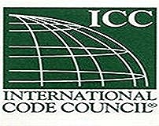
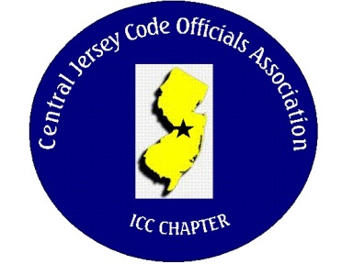
CJCOA

Central Jersey Code Officials Association

Call to Order: President Rich Perlman called the meeting to order on September 6, 2023 at 12:04 pm with 38 in attendance.

Guest Speaker: Austin Zebertavige and Skylar Wilson of Henry Building Envelpoe Systems.

Approval of Minutes: Minutes were approved.

Correspondence: No Report

Treasurer’s Report: Read by Treasurer Joe Voacola

Legislative Report: No Report

Finance & Audit Committee. No Report

Education Committee: October 4, 2023 – Civil Service Commission. All Human Resource Directors, DCA and Business Administrators’ are invited to attend and participate.

Membership Committee: Members paid in full to date. 105
Life Members. 22
Associate Members: 39

By-Laws Committee: No Report

Historical Committee: No Report

Good & Welfare Committee: Jeff Jay Boekhaut, son of Jack Boekhaut passed away and a Sympathy card was sent on behalf of CJCOA. A Get Well card was sent to Tony Scelsa on behalf of CJCOA.

Public Relations: Facebook is active and there are postings every so often.

Code Change Committee:

Building: No Report

Electric: No Report

Plumbing: No Report

Fire: No Report

Nominating Committee: No Report

Building Safety Week: No Report

Scholarship Committee: The applications for the scholarships and merit award are on our website. CJCOA.org

Website Committee: Our website is up to date and 2023 golf outing pictures are uploaded.

Golf Committee: Our 2023 golf outing was very successful. The 2024 golf outing will be held on June 6 at Mercer Oaks.

Ad-Hoc: No Report

DCA: No Report

ICC: No Report

ICC-Region 7: No Report

Unfinished Business: None

New Business: Civil Service of NJ has been invited along with various business administrators of Civil Service towns for October 4th. Meeting. Feel free to invite your Business Administers.

Announcements: Longbranch is looking for a full time Building Subcode Official. Lawrence is looking for a full time Building Subcode Official.

Meeting adjourned: 1:40 PM

Respectfully Submitted,

Frank Oliveti
Secretary

