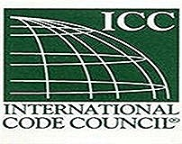
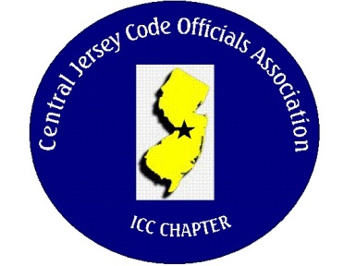
CJCOA

Central Jersey Code Officials Association

Call to Order: President Rich Perlman called the meeting to order on January 4, 2023 at 12:04 pm with 42 in attendance.

Guest Speakers: Assemblyman Wayne DeAngelo discussed the new “Electric Licensing” law and the new “Expedited Inspections” law. Michal Hofkin of UL discussed the proper ways to install and attach NM cable.

Approval of Minutes: Minutes were approved.

Correspondence: None

Treasurer’s Report: Read by Treasurer Joe Voacola

Legislative Report: No Report

Finance & Audit Committee. No Report

Education Committee: February 1st. guest speaker will be Greg Lavardera of Warm Form Insulation Slab Forms.

Membership Committee: Members paid in full to date. 158
Life Members. 22
New Members:
By-Laws Committee: No Report

Historical Committee: No Report

Good & Welfare Committee: Thank card was received from Joe and Dave Voacola for the passing of their mother.

Public Relations: No Report

Code Change Committee:

Building: Meeting was cancelled

Electric: 2026 NEC is in for public comment

Plumbing: No Report

Fire: No Report

Nominating Committee: No Report

Scholarship Committee: Adam Gee will be the new chairman.

Website Committee: Please forward any pictures from the ABM to Joe Voacola. E-mail them to jvoacola@westwindsortwp.com

Golf Committee: The date for the golf outing will be June 8 @ Mercer Oaks. More details to follow.

Ad-Hoc: No Report

DCA: No Report

ICC: No Report

ICC-Region 7: None

Unfinished Business: None

New Business: No report

Announcements: No Report

Meeting was adjourned: 2:20 PM

Respectfully Submitted,

Frank Oliveti
Secretary

