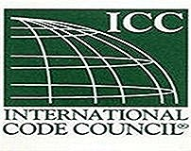
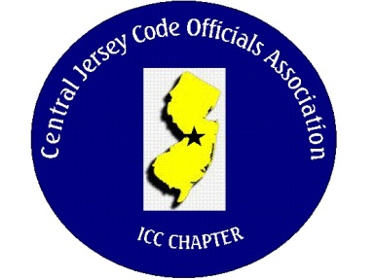
CJCOA

Central Jersey Code Officials Association

Call to Order: President Rich Perlman called the meeting to order on April 5, 2023 at 12:10 pm with 30 in attendance.

Guest Speaker: Rich Perlman and the members discussed “Expedited Inspections” and “Electronic Plan Review.”

Approval of Minutes: Minutes were approved.

Correspondence: No Report

Treasurer’s Report: Read by Treasurer Joe Voacola

Legislative Report: No Report

Finance & Audit Committee. No Report

Education Committee: May 3rd. guest speaker will be Matt Suckley from Eaton and will be speaking about short circuit calculations, AIC ratings and arc faults.

Membership Committee: Members paid in full to date. 104
Life Members. 22
New Members:

By-Laws Committee: No Report

Historical Committee: No Report

Good & Welfare Committee: A get well card was sent to Rich Such who is recovering from hip surgery.

Public Relations: Facebook is active and there are postings every so often.

Code Change Committee:

Building: No Report

Electric: No Report

Plumbing: No Report

Fire: No Report

Nominating Committee: No Report

Building Safety Week: May 3, 4 & 5 at The Hard Rock in Atlantic City

Scholarship Committee: Adam Gee will be the new chairman.

Website Committee: Please provide any job postings to our webmaster Joe Voacola.

Golf Committee: The date for the golf outing will be June 8 @ Mercer Oaks. More details to follow. The golf committee is looking for volunteers and gifts for door prizes.

Ad-Hoc: No Report

DCA: No Report

ICC: No Report

ICC-Region 7: No Report

Unfinished Business: We are discussing how CJCOA can be involved with trade schools.

New Business: No report

Announcements: Pemberton and Hamilton are looking for building inspectors.

Meeting adjourned: 1:32 PM

Respectfully Submitted,

Frank Oliveti
Secretary

