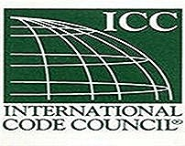
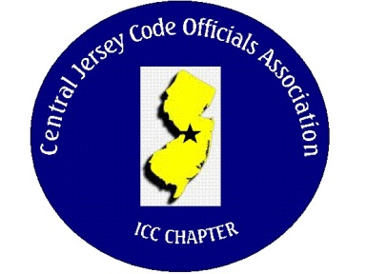
CJCOA

Central Jersey Code Officials Association

Call to Order: President Rich Perlman called the meeting to order on June 7, 2023 at 12:12 pm with 26 in attendance.

Guest Speaker: Michael Hofkin of UL

Approval of Minutes: Minutes were approved.

Correspondence: No Report

Treasurer’s Report: Read by Treasurer Joe Voacola

Legislative Report: No Report

Finance & Audit Committee. No Report

Education Committee: September 6, 2023 – Nancy Medl – Henry Building Envelopes and will be talking about Henrys complete weatherization solutions for residential and commercial construction.

Membership Committee: Members paid in full to date. 105
Life Members. 22
Associate Members: 39

By-Laws Committee: No Report

Historical Committee: No Report

Good & Welfare Committee: No Report

Public Relations: Facebook is active and there are postings every so often.

Code Change Committee:

Building: No Report

Electric: No Report

Plumbing: No Report

Fire: No Report

Nominating Committee: No Report

Building Safety Week: No Report

Scholarship Committee: Adam Gee will be the new chairman and will include trade school scholarships. Note, no determination has been made on what qualifications will be necessary.

Website Committee: Please provide any job postings to our webmaster Joe Voacola.

Golf Committee: 126 Golfers have paid and will include 7 active duty service members.

Ad-Hoc: No Report

DCA: No Report

ICC: No Report

ICC-Region 7: No Report

Unfinished Business: We are discussing how CJCOA can be involved with trade schools.

New Business: Civil Service of NJ has been invited along with various business administrators of Civil Service towns for October 4th. Meeting. Feel free to invite your Business Administers
Announcements:

Meeting adjourned: 1:30 PM

Respectfully Submitted,

Frank Oliveti
Secretary

